

**SOFTWARE PROJECT REPORT**

**Title: SPORTS STAR SEEKER**

**By: Usman Soormo, Adarsh kumar (20SW041, 20SW117)**

**Submitted to: Ma’am Mariam**

**Real-world problem identification:**

In a world where recognizing sportspersons from images is a common challenge, individuals, sports fans, and trivia enthusiasts often struggle to identify famous athletes in scenarios like trivia games, social media, live sports events, and educational needs. Streamlining this process can enhance entertainment, social engagement, fan experiences, and accessibility for all.

**Proposed solution:**

To address the widespread challenge of identifying sportspersons from images, we propose the development of an innovative image recognition application, built using the Flutter framework. Leveraging advanced machine learning and computer vision technologies, this Flutter-powered app will empower users to simply upload or capture a sportsperson's image and receive instant, accurate information about the athlete, including their name, sport, achievements, and relevant details. This solution aims to enhance the user experience across various scenarios, from trivia games and social media interactions to live sports events and educational pursuits. By providing quick and reliable athlete identification, our app, developed with Flutter, will bridge the gap between sports enthusiasts and the wealth of information available about their favorite athletes, making it a valuable tool for fans, gamers, educators, and individuals with diverse needs.

**Responsive user interface:**

**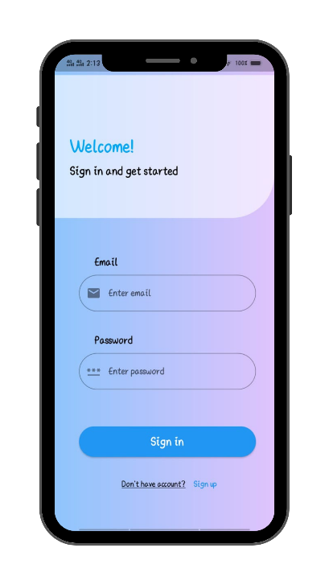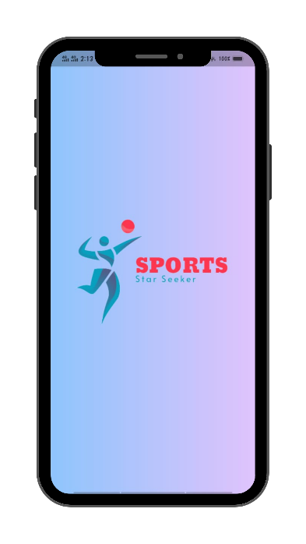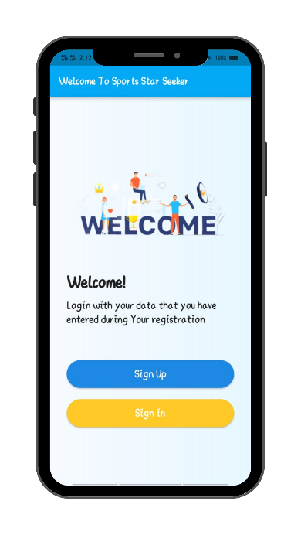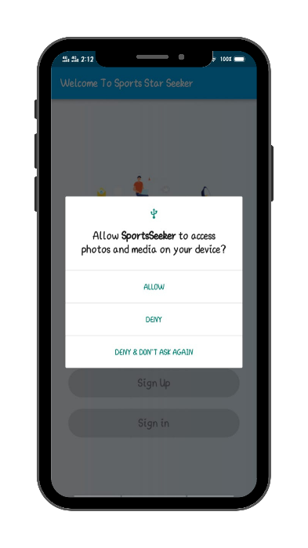  
 Splash Screen Welcome Page Requesting Permission**

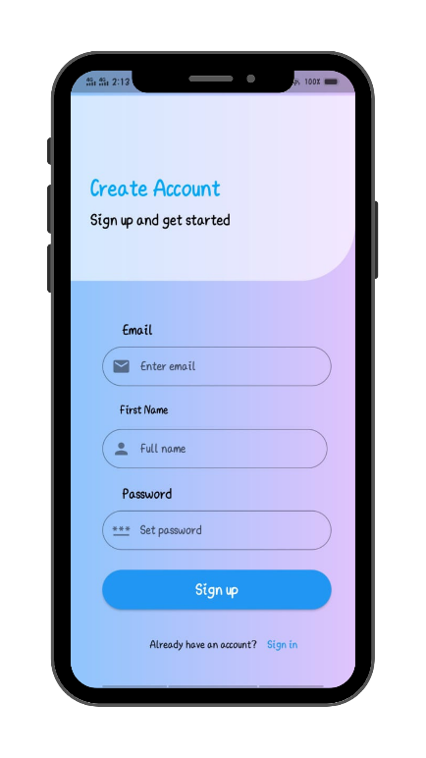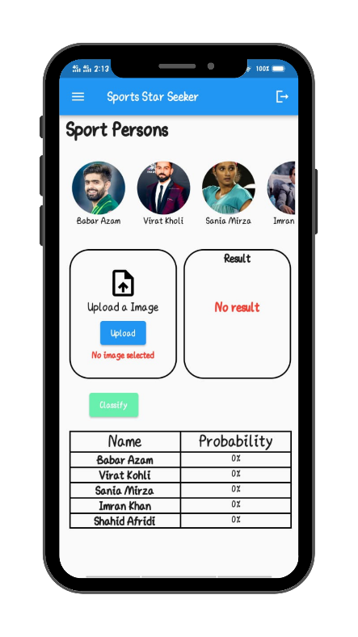

**Login Page Sign up Page Main Screen**

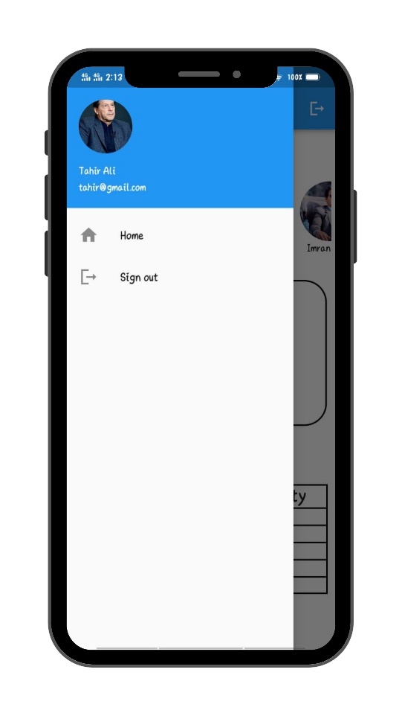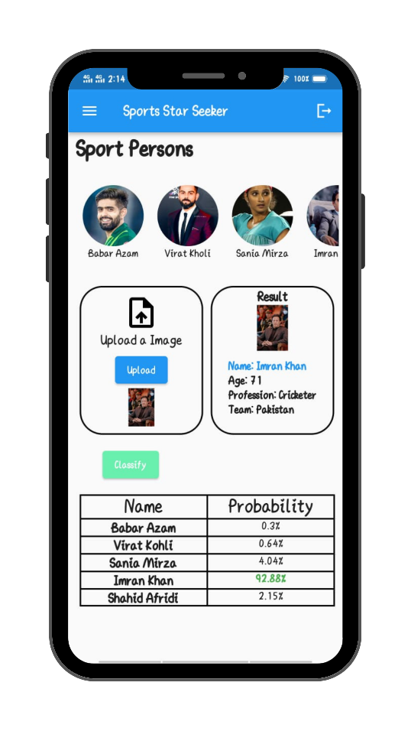

**Drawer Result**

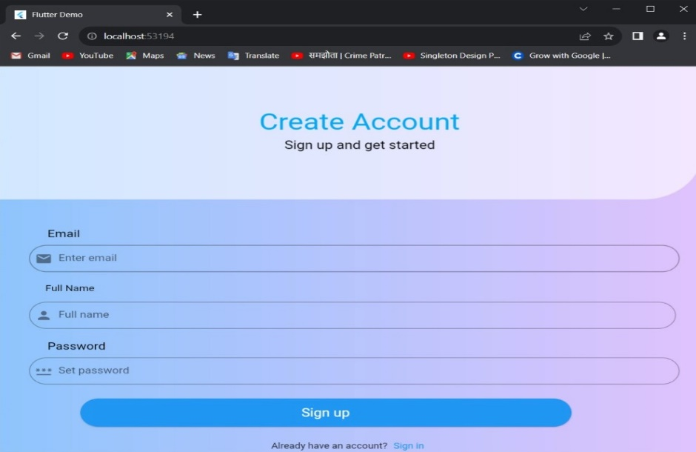

**WEBSITE VIEW**

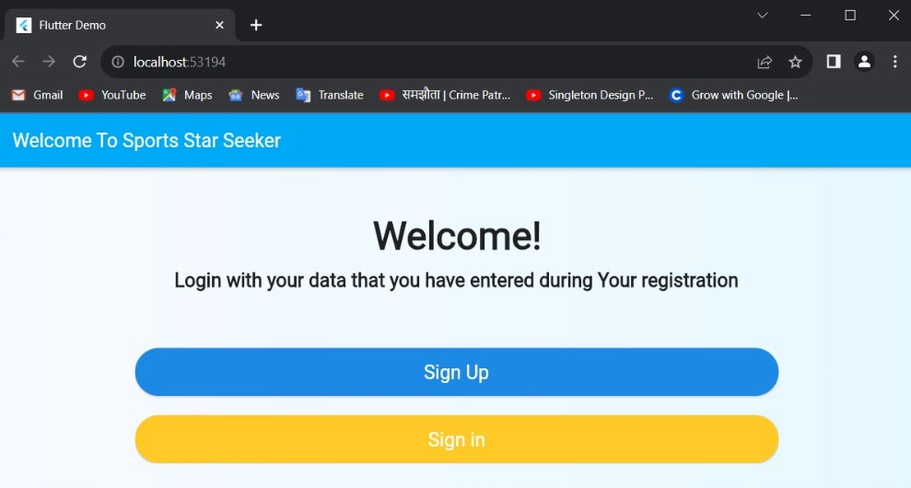

**Welcome page Website**

**Data storage:**

This project utilizes Firebase for user authentication and data storage. Below is an overview of the data structure and how user information is managed.

**Firebase Authentication**

The application employs Firebase Authentication to handle user sign-up and sign-in functionalities. User credentials, including email and password, are securely stored in Firebase Authentication.

**User Data**

Once a user is authenticated, additional information such as name and other profile details are stored in the Firebase Firestore database.

**Collection:** users

**Document ID:** Firebase UID of the user

**Fields:**

**uid:** Firebase UID (automatically generated)

**Email:** User's email address

**Name:** User's full name

**API’s**

We trained the machine learning model first and then created the server using Python Flask and then deployed that server on pythonanywhere.com

**usmansoomro.pythonanywhere.com/classify_image**

**Issues and bugs during development:**

**Error 1 :**

**=> When we access permission from the user through shared preference we gate this error.**

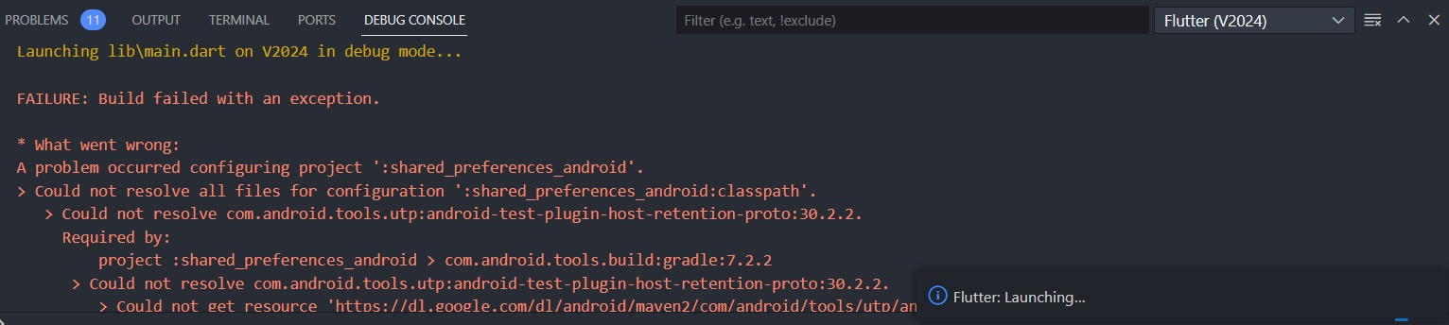

* **Add dependencies shared preferences and make the internet connection stable**

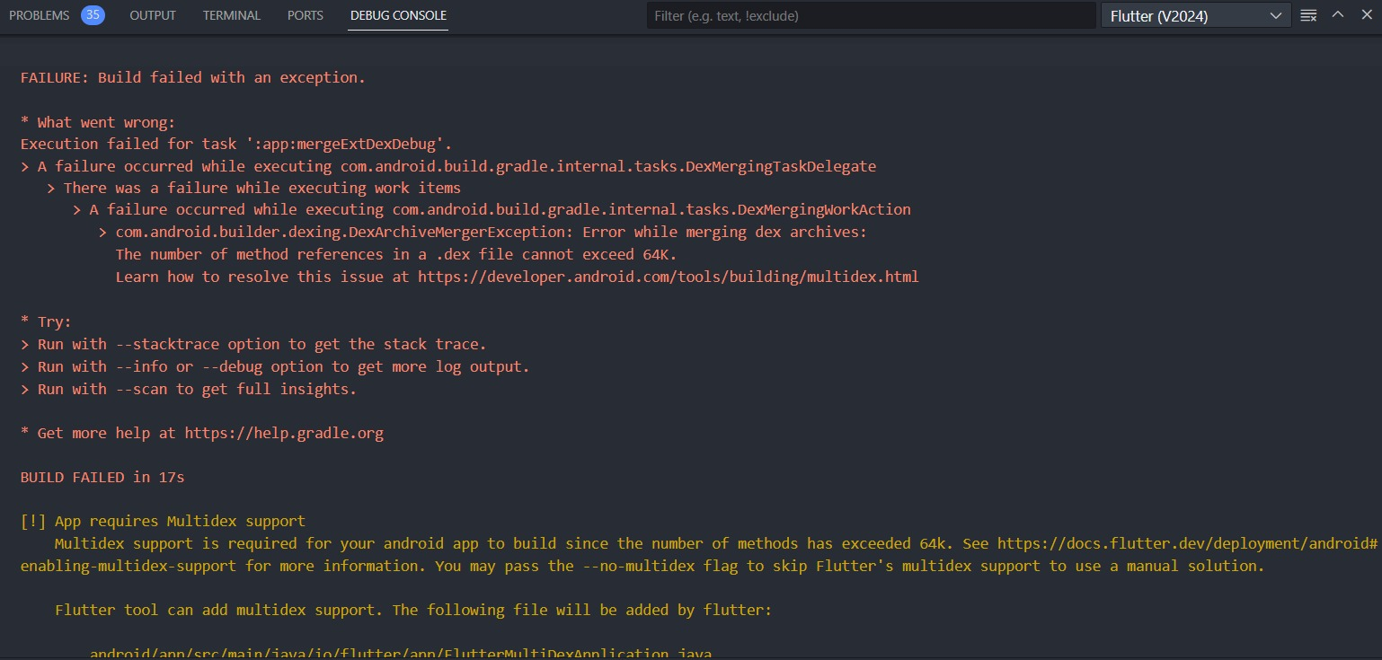

* **How we solve this error:**

**=>We have make changing in build.gradle in dependency section, also we have add com.android.support(“multdex:1.0.3”)**

**=>In default config section we have enable multidex “true”**

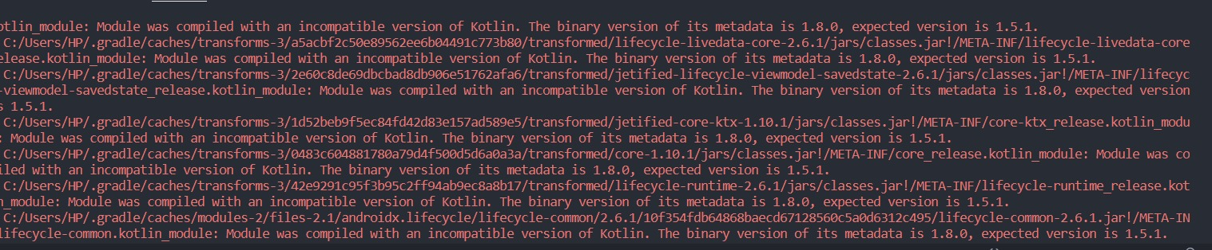

=>When we build APK, we get this error so we run these two commands

* flutter clean
* flutter upgrade